A000 Eur-France-Tursac-Venus-Calcite-25,000 BP

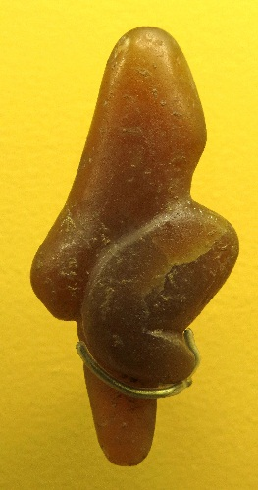

France-Tursac-Venus-Calcite-25,000 BP

Case No.: 1

**Formal Label:** France-Tursac-Venus-Calcite-25,000 BP

**Accession Number: A000**

**LC Classification:** GN772.2.M6

**Date or Time Horizon:** 25,000 BP

**Geographical Area:** Tursac, a village in the Perigord, near Sarlat

**Map:**



Fig. 2. Map of Tursac after Delporte (1968).

**Cultural Affiliation:** Gravettian

**Medium:** yellowish light brown, translucent calcite

**Dimensions: Original, H 8.4 cm, W** 22.5 mm, T 37.4 mm (anteroposterior)  **Weight: Original,** 57.5 gm

**Provenance:** excavated on 5th August 1959 by Mr. Robert Antoine-Charles under the direction Prof. M. Henri Delporte at Tursac; now deposited at Musée d'Archeologie Nationale et Domaine, St-Germain-en-Laye.

**Condition:** Reproduction in resin.

**Discussion: “**The head is of subconical shape, with a flexed position, protruding belly and buttocks, arms not shown, thighs and legs clearly shown, heels slightly apart, and at the base possibly a protrusion to be set into sand or earth.

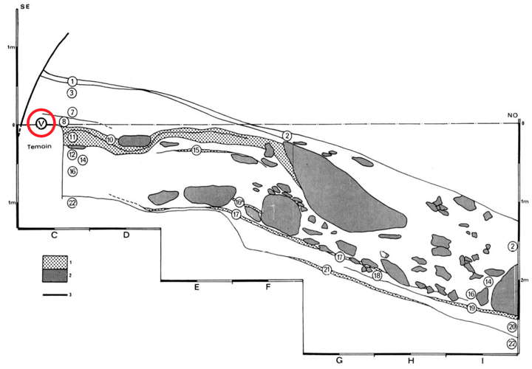

Fig. 3. Location of find in red circle. Grey indicates fallen roof slabs. After Delporte 1968.

Apart from a few very fine and superficial scratches on some of the surfaces and streaks of scratching from the erasure of marking ink, this statue shows an almost complete absence of evidence of shaping.  
Yet she was found in a rock solid context, and the form also leaves no doubt that this is a prehistoric sculpture. It was formed almost solely by abrasion and polishing. and not, as we assumed, by the techniques of scraping and cutting with flint tools Delporte” (1968).

**References:**

Delporte, H. 1959. “Une nouvelle statuette paléolithique: la Vénus de Tursac,” *L’Anthropologie*, 63: 232-245.

Delporte, H. 1960. “Problèmes d’interprétation de la Vénus de Tursac,” *Quartär*, 12: 119-129.

Delporte, H. 1968. “Étude générale, industrie et statuette,” *Gallia préhistoire*, 11(1): 1-112.

White, R. 2002. “Une nouvelle statuette phallo-féminine paléolithique: 'La venus des Milandes' (commune de Castelnaud-la-Chapelle, Dordogne,” *Paleo* N° 14 Décembre, pp.177-198.